**Citizen AI**

**Project Document**

**1.Introduction:**

* Project title : Citizen AI
* Team member : Syedshagulhameed .M
* Team member : Dilip .L
* Team member : Sathishkumar .B
* Team member : Udhayakiran .S

**2.Project overview:**

Citizen AI is an AI-driven civic engagement platform designed to strengthen the relationship between citizens and governance. By providing transparent access to information, tools for participation, and intelligent insights, Citizen AI empowers individuals to make informed decisions, voice concerns, and contribute to policy-making. The project envisions a future where artificial intelligence acts as a bridge between people and institutions, ensuring inclusive, accountable, and participatory governance.

**3.Objectives:**

* Empower Citizens : Provide accessible and simplified information on policies, rights, and services.
* Enhance Participation : Create a digital platform for civic discussions, consultations, and feedback.
* Promote Transparency : Ensure open communication between governments and citizens.
* Data-Driven Insights : Use AI analytics to capture public sentiment and inform better policymaking.

**4. Core Features:**

**1.**AI-Powered Knowledge Hub:

* Simplified explanations of government policies and laws.
* Multilingual support for inclusivity.
* FAQs and guides on civic rights and duties.

**2.**Citizen Feedback & Consultation Module:

* Platforms for surveys, polls, and petitions.
* Direct citizen inputs for policymaking.

**3.**Digital Civic Assistant:

* AI chatbot for real-time civic queries.
* Guidance on accessing government services.

**4.**Public Sentiment & Data Analytics:

* AI-driven dashboards showing public opinions.
* Data visualization for decision-makers.

**5.**Misinformation Detection:

* Tools to fact-check and combat fake news.

**5. Target Users:**

* General Citizens: Urban and rural communities.

Civil Society & NGOs: Advocacy and grassroots organizations.

Governments & Policymakers: To gather insights and build trust.

Academia & Researchers: For civic data and trend analysis.

**6. Technology Stack:**

* AI & NLP Models: For language understanding, translation, and sentiment analysis.
* Cloud Infrastructure: Secure, scalable hosting.
* Blockchain Integration (Future): For transparency and tamper-proof citizen inputs.
* Mobile & Web Interfaces: User-friendly, accessible across devices.

**7. Implementation Roadmap:**

* Phase 1: Research & Design:
* Requirement gathering, stakeholder consultation, ethical framework.
* Phase 2: MVP Development:
* Launch of AI Civic Assistant & Knowledge Hub.
* Initial deployment in select regions.
* Phase 3: Expansion & Integration:
* Add feedback tools, analytics dashboards.
* Partner with government bodies.
* Phase 4: Scaling:
* Nationwide roll-out with multilingual and offline capabilities.
* Integration with e-Governance systems.

**8. Expected Impact:**

* Increased civic awareness and participation.
* Stronger citizen-government trust.
* Policy decisions guided by real-time citizen feedback.
* A reduction in misinformation and improved accountability.

**9. Challenges & Risk Mitigation:**

* Data Privacy: Ensure secure handling of citizen data.
* Digital Divide: Provide offline/low-data solutions.
* Bias in AI Models: Adopt ethical AI practices and audits.
* Misinformation: Continuous monitoring and fact-checking.

**10.Screenshots:**

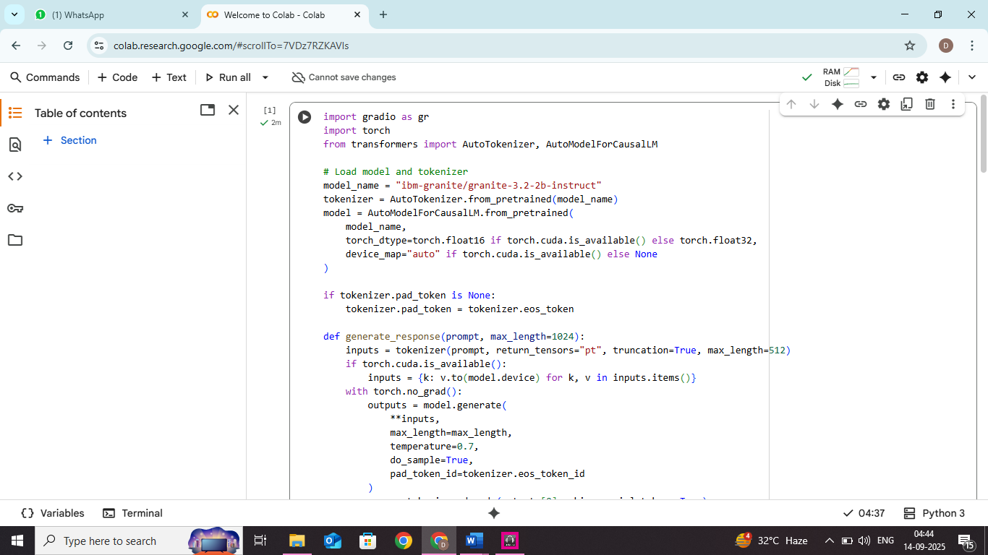

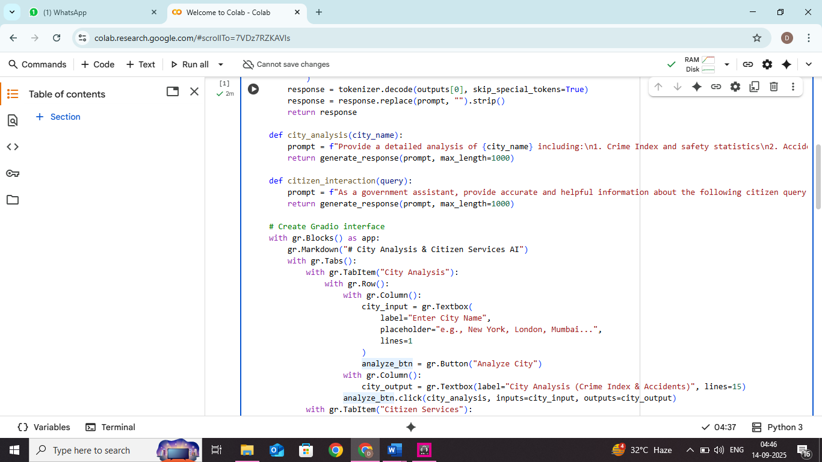

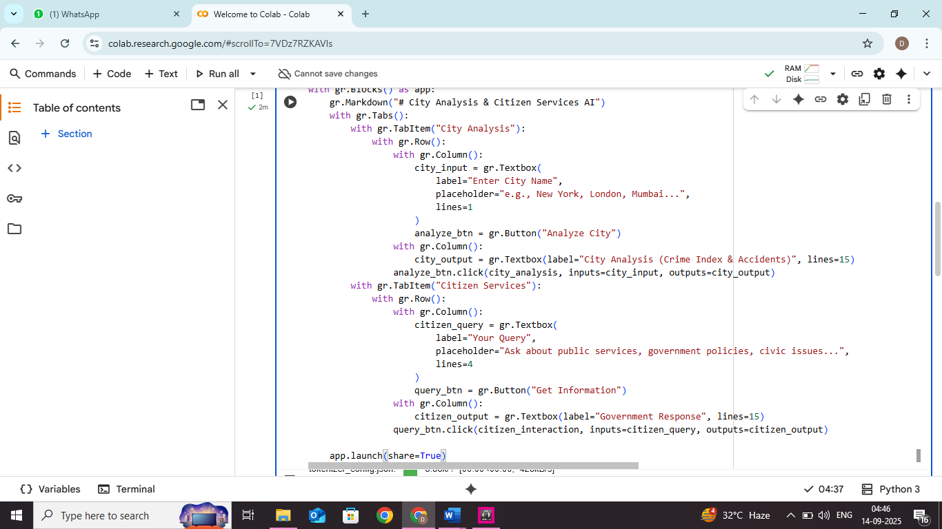

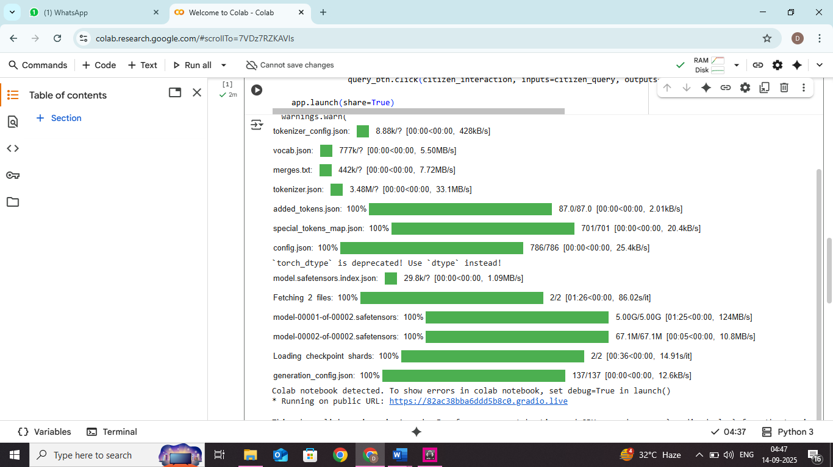

**11. Future enhancement:**

**1. Multilingual Support**– Interaction in multiple regional & global languages.

**2. Emotion & Sentiment Analysis** – Understanding citizen mood for empathetic responses.

**3. Smart City Integration** – Linking with e-governance, transport, health & education services.

**4. IoT Connectivity** – Real-time reporting of civic issues via smart devices.

**5. Automated Grievance Redressal** – AI-powered complaint routing & status tracking.

**6. Citizen Dashboards** – Personalized updates on local issues & participation opportunities.

**7. Blockchain Transparency** – Secure & transparent record-keeping of civic data.

**8. Digital Literacy Support** – AI tutors to guide citizens in using digital & civic tools.

**9. Accessibility Features** – Voice, text-to-speech & inclusive design for differently-abled citizens.

**10. Predictive Governance** – AI forecasting social challenges & guiding policy decisions.